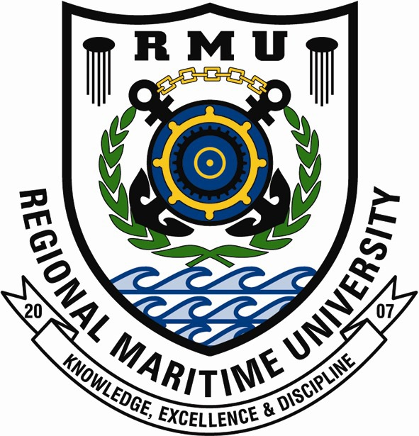

FACULTY OF ENGINEERING
DEPARTMENT OF ICT

TOPIC:
DESIGN AND DEVELOPMENT OF RMU STUDENT GRIEVANCE WEB APPLICATION
By Morden Elton John, (BIT0001526)
Joseph Agyemang, (BIT0004626)
Table of Contents
ACKNOWLEDGEMENT 3
ABSTRACT 4
TABLE OF CONTENTS 5
CHAPTER ONE - INTRODUCTION 5

CHAPTER ONE - INTRODUCTION
1.1 Introduction / Background
In modern higher education institutions, administrative efficiency and transparency are vital for maintaining trust between students and management. One critical area where these values are tested is in the handling of student grievances. Universities process a variety of petitions daily, including grade corrections, remarking requests, and administrative appeals. At the Regional Maritime University (RMU), this process is currently manual, relying heavily on paper forms, handwritten approvals, and physical signatures. While this traditional method has long served the institution, it is increasingly becoming inadequate in an era of digital transformation.
The manual grievance process is slow and prone to several administrative challenges. Petitions may be misplaced, delayed, or left unresolved due to bottlenecks in the approval chain. Students have limited visibility regarding the progress of their submissions, and administrators lack the tools to monitor workflow efficiency or generate comprehensive reports. These limitations often lead to frustration among students and difficulty in ensuring accountability and transparency within the institution.
To address these inefficiencies, this project proposes the design and implementation of a Student Grievance Management System (SGMS). The system seeks to digitize the petition submission and approval process, providing an automated, transparent, and trackable workflow. By introducing this system, RMU can streamline communication between students and university authorities, improve record-keeping, and enhance responsiveness in handling student-related issues.
1.2 Problem Statement
The existing student grievance handling procedure at RMU is entirely manual, involving physical forms and in-person submissions. This approach has several shortcomings, including delayed feedback, lack of data security, and absence of digital traceability. Students often do not know the current stage of their petitions, while staff members face challenges in monitoring or prioritizing requests.
Key challenges identified include:
- Slow processing due to physical routing of forms across departments.
- No real-time tracking or notification for students.
- Absence of an automated approval workflow.
- Limited accountability because actions are not logged or timestamped.
- Difficulty in generating reports and statistics for decision-making.
These issues create administrative inefficiency and reduce the overall quality of student services. Hence, there is a need for a centralized digital system that simplifies the grievance management process, enhances transparency, and ensures accountability at every level of review.
1.3 Aim of the Project
The aim of this project is to design and implement a web-based Student Grievance Management System for the Regional Maritime University that automates the grievance submission and resolution process, ensuring timely feedback, transparency, and accountability among students and administrative staff.
1.4 Objectives of the Project
The specific measurable objectives of the project are to:
1. Develop a secure web-based platform that allows students to submit petitions using institutional credentials.
2. Design a standardized electronic grievance form supporting document attachments.
3. Implement a structured approval workflow following the RMU hierarchy: Student → Class Advisor → Head of Department → Registrar.
4. Enable digital approvals and feedback using notifications, email, or OTP verification.
5. Provide dashboards for each user role to manage and track petitions efficiently.
6. Maintain an audit trail for transparency and performance review.
7. Generate analytical reports for administrative assessment and decision-making.
1.5 Significance of the Study
The Student Grievance Management System will provide a reliable and transparent framework for processing student petitions. By automating manual tasks, the system will reduce administrative workload, minimize delays, and eliminate loss of records. It will enhance communication between students and staff, improve the quality of service delivery, and support institutional accountability. Moreover, the data generated by the system can be used to identify recurring issues and guide policy reforms aimed at improving student satisfaction.
1.6 Scope of the Study
This project focuses on developing a digital grievance management system for the Regional Maritime University. It covers the processes of submission, approval, and resolution of petitions such as grade corrections and remarking requests. The scope includes all levels of processing from students to the registrar. However, the study excludes appeals handled outside the university’s internal administrative structure.
1.7 Outline of the Research and Report
This report is organized into five chapters as follows:
- Chapter One introduces the background, problem statement, aim, objectives, significance, scope, and organization of the report.
- Chapter Two presents the literature review, highlighting existing systems, research works, and technologies related to grievance management.
- Chapter Three describes the methodology adopted for system design and implementation, including tools and frameworks used.
- Chapter Four discusses the results, findings, and system testing outcomes.
- Chapter Five provides conclusions and recommendations for further development and improvement of the system.

